**Building a mobile app using Xamarin and Visual Studio 2017 Community Edition (free ☺)**  
Install Visual Studio from here:  
<https://visualstudio.microsoft.com/vs/>

Then follow the installation steps here:  
<https://docs.microsoft.com/en-us/xamarin/cross-platform/get-started/installation/windows>

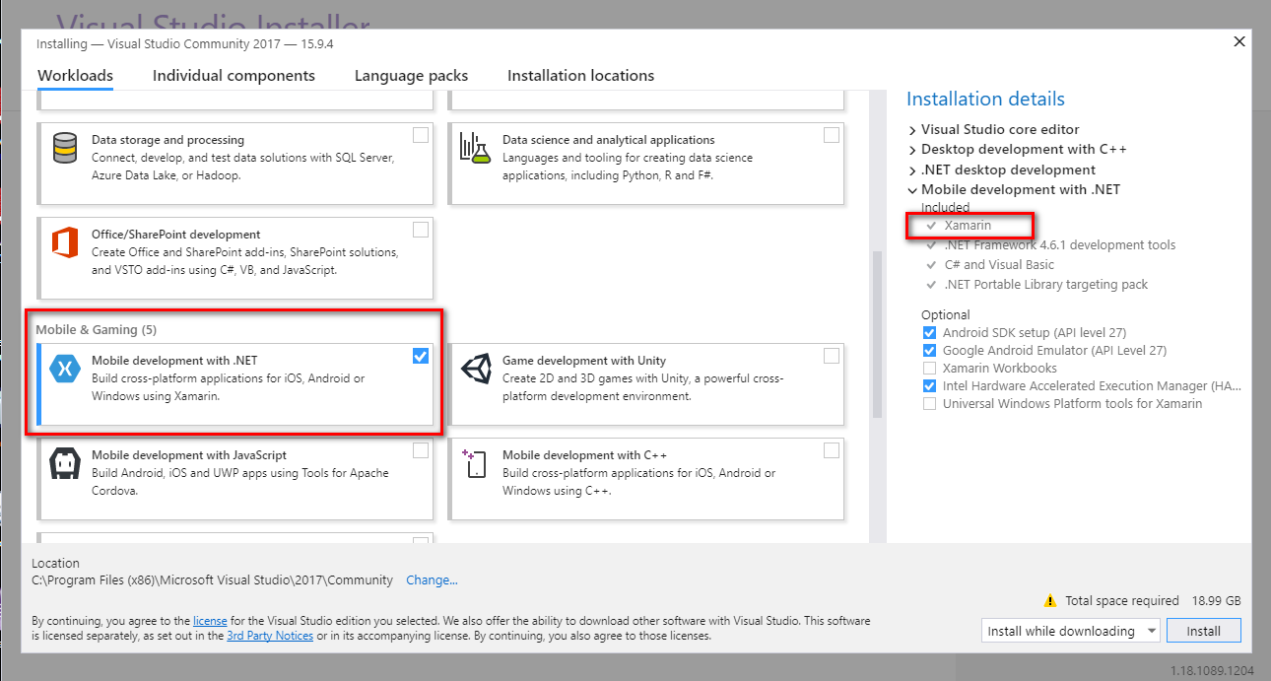  
Then click the “Install” button. **NOTE:** The installation requires around 15Gb disk space (C drive).  
  
To verify that Xamarin has been installed:  
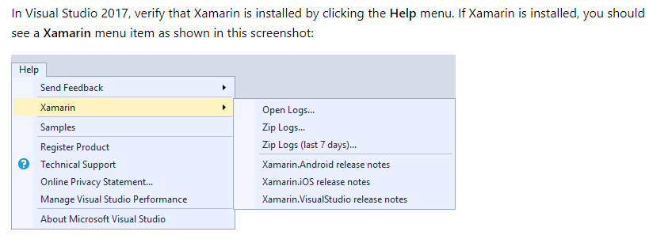

**Installing MvvmCross (a framework for creating cross-plaform apps that use the MVVM pattern)**From Visual Studio, select “Tools > Extensions and Updates…”. This will bring up a dialog box to allow you to add or remove extensions. From here, search for “MvvmCross”:  
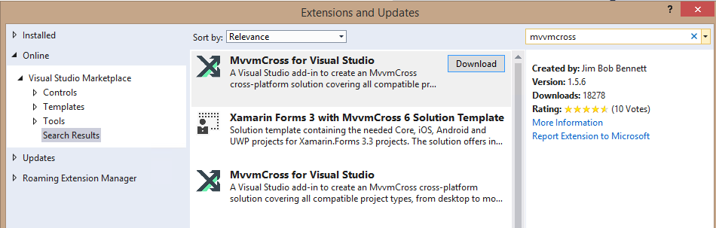  
Once this is installed, restart Visual Studio.  
  
Create a new solution using “File > New > Solution” and choose “MvvmCross Single Page Native Application” under the “Other > .NET” section:  
  
***tbd***  
Click Next. On the next screen enter “HelloCrossPlatformWorld” as the project name and click Create. This will create a new solution for you containing three projects: a .NET Standard core project (HelloCrossPlatformWorld.Core), an iOS app (HelloCrossPlatformWorld.iOS), and an Android app (HelloCrossPlatformWorld.Droid):  
  
***tbd***

*JeremyC 19-12-2018***END**